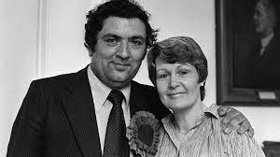
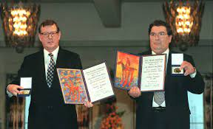
Ireland’s Greatest?
The Life and Legacy of John Hume

co-recipient of the 1998 Nobel Peace Prize with David Trimble

This worksheet links to Miriam O’Callaghan’s “Ireland’s Greatest” documentary: https://www.youtube.com/watch?v=paBd7vSJtbU&t=647s

How does this content link to our course?
Learning Outcome 2.5 - Identify the Course, Course, and Consequences of the Northern Ireland ‘Troubles’ and their impact on North-South and Anglo-Irish Relations
Learning Outcome 1.9 – Importance or Irish and European History in “political, social, economic, religious, cultural and scientific dimensions” (Which of these best applies to the history of Northern Ireland and the work of John Hume?)
Learning Outcome 2.2 - investigate the role and significance of two leaders involved in the parliamentary tradition in Irish politics.
- Hume was a member of THREE parliamentary bodies! Northern Ireland Parliament(s) firstly as an Independent Nationalist member of the Parliament of Northern Ireland in 1969 at the height of the civil rights campaign. He was also elected to the Northern Ireland Assembly in 1973, and served as Minister of Commerce in the short-lived power-sharing Executive in 1974.
- He also stood unsuccessfully for the Westminster Parliament for the Londonderry constituency in October 1974, and was elected for Foyle in 1983.
- He also served as a Member of the European Parliament for Northern Ireland between 10 June 1979 – 13 June 2004.

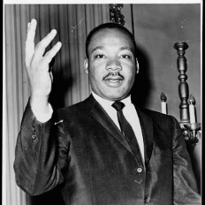
- Who was John Hume’s political hero? What principle did he most admire? (2:00)
Name: _________________________ - Principle _____________________________
- Approximately how many people died during “The Troubles”? __________________
- Hume’s father used to say – “Son, you can’t eat a _________________”.
- Where did John Hume Grow up? What was his economic background? ________________________________________________________________________________________________________________________________________________________________________
- What are the 3 main principles the describe Hume’s approach to conflict: ___________________________, _________________________, and ___________________________
- How did Hume advance his education? ________________________________________________________________________________________________________________________________________________________________________
- What economic movement influence the young Hume? ____________________________________________________________________________________
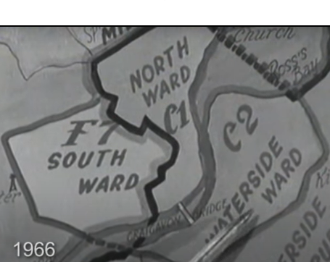
- How did the housing situation impact Derry’s Catholic/Nationalists? What action did Hume take to address this? (6:45) ________________________________________________________________________________________________________________________________________________________________________
- Where were the Catholic/Nationalists of Derry ‘Corralled’ (grouped together)?Why_______________________________________________ ___________________________________________________________
This is known as G__________________________

- What three “Blatant Social Injustices” did the young Hume say Catholics faced? ____________________________________________________________________________________
- Hume quit teaching and set up a fish processing company so nationalists would help t______________
- In 1965 Hume lead a protest to be Ulster’s second U____________________ to Derry, but instead it ended up being established in the mainly Protestant town of C_____________________. (11:05)
- The MEDIA (mainly TV cameras) changed the nature of Civil Rights protests in the US and Ireland? What phrase did the protesters chant? “The whole world is W_____________________”
Extended writing – From your engagement with this part of the video (and the information you’ve listed below) write a short paragraph answering the following question:
What discrimination was faced by Catholic/Nationalists in Northern Ireland in the 1950s and 1960s?
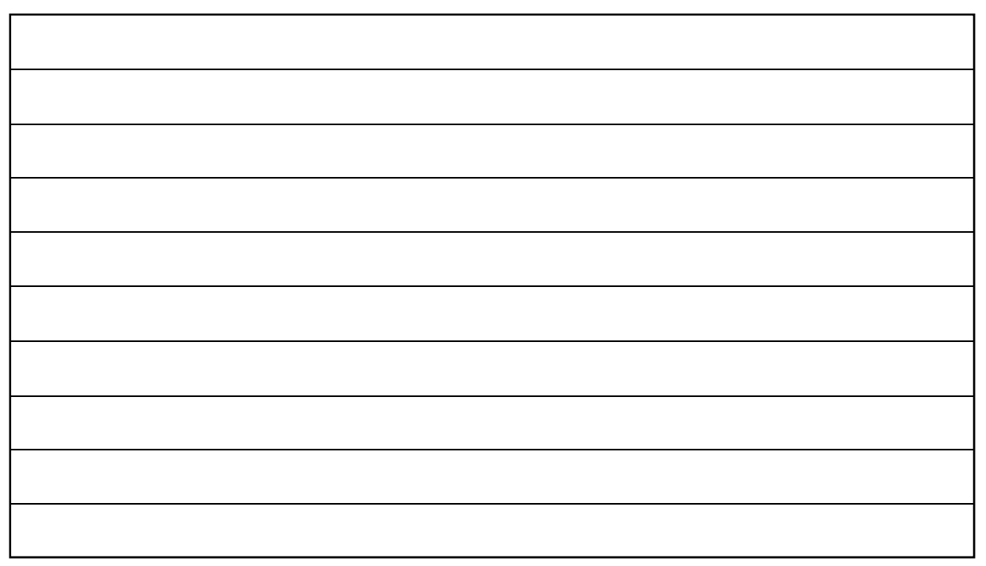
- Which American Senator telegrammed Hume with support?(12:30) _____________________________
- Where did Hume attend University (initially intending to join the priesthood)? M__________________
Part 2 of YouTube video
- Hume wanted to end SECTARIANISM. What does this term mean? ________________________________________________________________________________________________________________________________________________________________________
- The THREE STRANDS involved cooperation between which groups?
  - _____________________ and ______________________
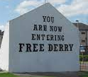
  - _____________________ and ______________________
  - _____________________ and ______________________
- What was “Free Derry”? ________________________________________________________________________________________________________________________________________________________________________
- Which political party did Joh Hume found? (Abbreviation and full name) Abbreviation: _____________ Full Name: ___________________________________________________________________________
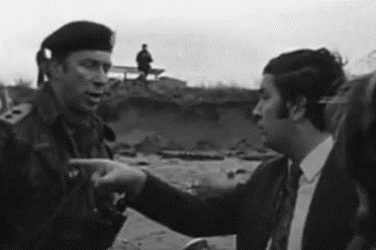
- Where did Hume march on 22nd -January 1972 and what happened there? ___________________________________________________________________________________________________________________________________________________________________________________________________
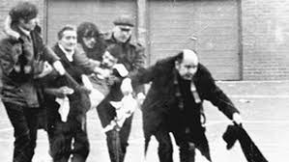
- What position did Hume take relative to the march planned for the following Sunday? What happened on that march? ____________________________________________________________________________________________________________________________________________________________________________________________________________________________________________________________________________________________________________________________________________________________________________________________________
- Why was Hume criticised by his own side (i.e. other nationalist groups)? ________________________________________________________________________________________________________________________________________________________________________
Extended writing – From your engagement with this part of the video (and the information from your own study) write a short paragraph answering the following question:
What challenges did John Hume experience during ‘The Troubles’?
- With which other prominent Irish-American politicians did Hume engage? (The “Four Horsemen”)
  - ____________________________ (Senator from Boston)
  - ____________________________ (Speaker of the US House of Representatives – 2nd in line for the Presidency)
  - ____________________________ (Governor of New York)
  - ____________________________ (Senator from Ney York)
- What did US President Jimmy Carter call for in his 1977 speech? ____________________________________________________________________________________

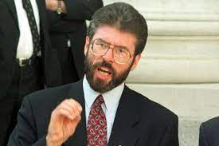
- Who did Hume recommend should be granted a visa to visit America? Why was it controversial to invite the head of Sinn Féin? _____________________________________________________________ _____________________________________________________________
- According to O’Callaghan, what was Hume’s greatest act of achievement in the 1980s? (11:00)
Name of the Agreement: _______________________________________________________________
- How did the economic situation change because of this agreement? ________________________________________________________________________________________________________________________________________________________________________
Part 3 of YouTube video, but skip to timecode 1:20!

- Name the major business did Hume bring to Derry? ____________________________________________________________________________________
- What new political position did Hume take up in 1979? ____________________________________________________________________________________

- In his Nobel speech, Hume said that the “Answer to difference is to _____________________”
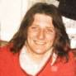
- Why did the Hunger Strikers protest? Name the most prominent Hunger Striker? ________________________________________________________________________________________________________________________________________________________________________
Name of the most prominent Hunger Striker: Bobby ______________________________
- Which prominent bombing on Remembrance Day 1987 made Hume more determined?
Town: _______________________________________________________________________________
- What meetings started to take place in Clonnard in 1988? ____________________________________________________________________________________
- These meetings were risky because nobody wanted to be seen talking with T_____________________
Part 4 of video
- What happened in 1993 to put this process at risk? ____________________________________________________________________________________
- Seven of the Darkest Days of the Troubles:
  - Where did the IRA bomb in October 1993? ____________________________ on the Shankhill Road.
  - b. What pub did Unionist paramilitaries attack? The R______________ S________ bar in Greysteele.
- What accord (Agreement) was signed in 1993? The __________________ Street Declaration
- What happened within one year of this accord? ____________________________________________________________________________________
- Where was bombed in 1996? Why was this significant? ________________________________________________________________________________________________________________________________________________________________________
- What was the result of the “Good Friday Agreement” referendums? (5:25) Northern Ireland Yes: ______% No: ______% Republic of Ireland Yes: ______% No: ______%
- With which Unionist did John Hume Share the Nobel Prize? What did Hume do with the prize money? ____________________________________________________________________________________
- What phrase from the US Civil Rights movement did John Hume quote at the end of his Nobel speech?
“We shall O______________________”
Extended Writing: Based on the evidence in the video and your own study, do you think Miriam O’Callaghan is justified in thinking that John Hume was ‘Ireland’s Greatest’? Explain your answer with particular reference to “The Troubles” in N.I. and the “Peace Process” that emerged.
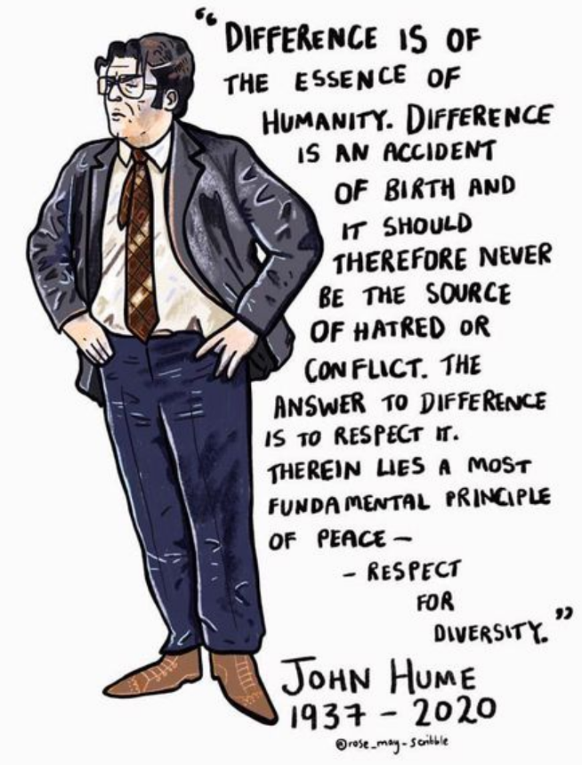

Gerrymandering: Separate the following “X”s (36) and “O”s (24) into THREE equally-sized Wards in such a way that the “O”s have a TWO to ONE overall majority. (Draw the lines)
X X X X X X X X X X X X X X X X X X X X X X X X X X X X X X X X X X X X O O O O O O O O O O O O O O O O O O O O O O O O

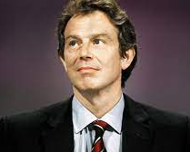
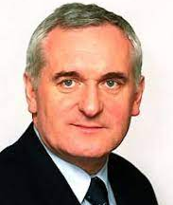
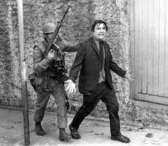
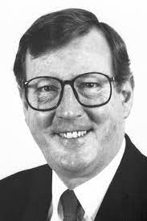
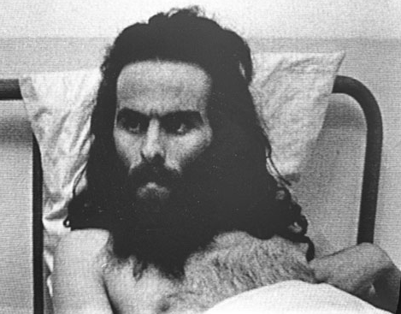
“Who’s who?” - Matching Exercise

Dies in 2020
David Trimble MP
Ulster Unionist Party Leader

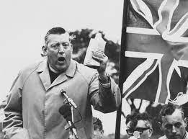
↓Create a timeline of the key events of John Hume’s life↓
Consider using some of the following events: Sunningdale Agreement, Anglo-Irish Agreement, Good Friday Agreement, Downing Street Declaration, Founding of NICRA & SDLP, Bloody Sunday, Battle of the Bogside, Coleraine University Controversy. What else???
Born, Derry, 1938
Tony Blair MP
Labour Prime Minister of the UK
Bertie Ahern TD
Taoiseach in 1998 during the GFA
Bobby Sands MP
Hunger Striker
Reverend Ian Paisley
Democratic Unionist Party Leader
John Hume MP
S.D.L.P. Leader

