Neoliberalism:
The Political Spectrum:
Left/Centre/Right Candidates
Selecting an Executive:
2 Rounds and “Run Off” elections
Impact of Globalization:
US ‘Rust Belt’ and French Industry
Work ‘Smart’ – Identifying case studies that work “across the course” – French Presidential Elections
Oftentimes, you’ll want to be able to refer to ‘contemporary’ events as evidence of your broader engagement with elements of the course. The recent elections in France illustrate many of these trends. Under each of the headings below, jot down briefly how they refer to different essay topics…

Where else do we see links to the
French Presidential Elections
on the Pol-Soc Course?
Pro/Anti EU Stances:
EU and Brexit
Separation of Powers:
The Role of the French President

Migration: Linking French ‘Colonialism’ with current politics
Nationalism and Identity
What does it mean to be ‘French’?

You’ll notice, inevitably, that there are some obvious overlaps between these 8 sub-headings. But it’s also important to recognize that the nature of the multiple ‘Strands’ of the Pol-Soc Specification mean that showing these kinds of links within an essay can be a sign of strength and insight rather than a weakness.
Use the articles (i.e. potential DBQ texts!) on the following pages to complete the grid above and make the kinds of necessary links.
In each case comment on the following: The viability of the source, the argument being presented, the chronology of events (Causes, Key Events, Consequences)
And as with all things Pol-Soc don’t forget that we always need to consider the “Role of the Media” in every case study!

‘Frexit in all but name’: what a Marine Le Pen win would mean for EU
https://www.theguardian.com/world/2022/apr/15/frexit-what-marine-le-pen-win-mean-eu
The Guardian: 15/4/22 Jon Henley & Jennifer Rankin (adapted for exam purposes)
It is feared if far-right candidate becomes French president she will try to destroy the bloc from inside
Campaigning in Burgundy the day after reaching the second round of France’s presidential elections, Marine Le Pen could not have seemed clearer: “I do not want to leave the EU,” she said. “That is not my objective.” Much of what the far-right Rassemblement National (National Rally) leader does want to do, however – on the economy, social policy and immigration – implies breaking the EU’s rules, and her possible arrival in the Élysée Palace next weekend could prove calamitous for the 27-member bloc.
Le Pen may have dropped previous pledges to take France – a founder member of the EU, its second-biggest economy and half of the vital Franco-German engine that has powered it since its creation – out of the euro single currency and the bloc.
In the 2017 election, fears of the economic consequences of that policy, above all among older voters worried about their savings, are widely seen as having contributed to her heavy second-round defeat against the pro-European Emmanuel Macron. This time, the EU does not even feature by name among the dozen or so key themes of Le Pen’s electoral programme. Many of her concrete policy proposals, however, blatantly contradict the obligations of EU membership.
Opponents and commentators have called the strategy “Frexit in all but name”: an approach that, while it may no longer aim to remove France from the bloc, seeks to fundamentally refashion it, and that could lead to a paralysing standoff with Brussels. “Le Pen’s EU policy is: ‘We’re going to stay in the bus but drive it off a cliff,’” said Mujtaba Rahman, the Europe director of Eurasia Group consultancy. It would “try to destroy EU from the inside” and was “a much greater threat to the EU status quo than Brexit”, he said.
Pascal Lamy, who was chief of staff to the former European Commission president Jacques Delors, said a Le Pen victory would be a major shock on a bigger scale “than Trump was for the United States, or Brexit for the UK”. Her “sovereigntist, protectionist, nationalist” agenda would “totally contradict the French commitment to European integration” and includes “proposals which are in total breach of the treaties to which France has subscribed,” he said.
Key to Le Pen’s plans is an early referendum on a proposed law on “citizenship, identity and immigration” that would modify the constitution to allow a “national priority” for French citizens in employment, social security benefits and public housing – a measure incompatible with EU values and free movement rules. Le Pen’s plans include a ‘national priority’ for French citizens in areas such as public housing.
The same referendum would establish “the primacy of national law over European law” to allow France “not only to control immigration but, in every other area, reconcile its European engagement with the preservation of its national sovereignty and the defence of its interests”, her RN party says. The aim would be to enable France to benefit from a “Europe à la carte”, picking and choosing from the bits of EU legislation it likes and dislikes – a non-starter for the bloc that was forcefully ruled out by the 27 during Brexit negotiations with the UK. “It’s absurd,” said Jean-Louis Bourlanges, a centrist MP and president of the French parliament’s foreign affairs committee. “As soon as you affirm the primacy of national law, you have no European law. Marine Le Pen has rejected an official exit, but her programme is not compatible with continued French membership of the EU.”
Le Pen also aims to re-establish border controls on imports and people, violating EU and Schengen rules, and unilaterally cut France’s contribution to the EU budget – when the bloc’s multi-annual financial framework for 2021 to 2027 is already fixed. Further plans to cut taxes on essential goods and fuel would breach EU free market rules.
Big questions may remain about how much of this programme could be implemented, domestically and in an EU context. Le Pen’s ambitions would be thwarted if she failed to win a parliamentary majority in elections in June, and EU legal experts have pointed out that even so much as holding a referendum on the primacy of national law would be in breach of European treaties.
French lawyers also say the country’s highest court, the constitutional council, would throw out Le Pen’s plan for a referendum by presidential decree – avoiding the need for parliamentary approval – precisely because any referendum intended to modify the constitution must have the backing of MPs and senators.
The EU as it exists today, Le Pen said earlier this year, was “neglectful of peoples, and domineering of nations”, an “intrusive and authoritarian” bloc locked into “a globalist, open-border ideology” that was “destroying our identity”.
Her vision, she said, was of an “alliance of nations … respectful of peoples, histories and national sovereignties”, whose members could “favour their own businesses for public contracts” and “re-establish permanent checks” on their borders.
But even if she failed to declare the primacy of French law and establish a national preference, the small print in Le Pen’s programme seems certain to lead France inexorably down the road towards a conflictual relationship with the EU – with political chaos the consequence given France’s indispensable role within the bloc.
“She could totally put [the EU] into gridlock or paralyse it,” said Georg Riekeles, a former European Commission official, who forecast “a dramatic weakening” of the EU’s ability to deal with crises, from security to the climate.
Le Pen has vowed to pull France out of NATO’s integrated command structure, removing troops and weapons from common management. She also wants to dismantle French windfarms, a strike against France’s EU renewable energy targets. “Any topic will just be more complicated,” Riekeles said.
EU insiders worry that a France led by Le Pen would also provide a major boost to national-conservative governments in countries such as Poland and Hungary, potentially allying with capitals that have long challenged the supremacy of EU law and are locked in battle with Brussels.
“It would stop every attempt to change things in Poland and Hungary,” said the French MEP Gwendoline Delbos-Corfield, who works on the rule of law. While the Green MEP believes the EU’s institutions and single market would continue under a Le Pen presidency, she thinks it “would be the end of a rule of law, values-based European Union”.
For the EU, a President Le Pen could mean a five-year “empty chair” crisis, Lamy suggested, referring to the events of 1965 when the then French president, Charles de Gaulle, boycotted the European institutions in a row over the budget.
“For certain, it would be a big problem, short term, during the next five years,” he said. “I have a hard time believing that if she was elected with the programme that she has, she would be re-elected.”

Linking to the Course: Using the content here, complete the following opening sentences a guidelines.
“Frexit reminds me of Brexit because…..

“I can see the influence that Globalization had on the French Presidential election when I note that…

“The French Presidential elections demonstrated two contrasting views on French culture and identity because…

“Supranational organizations like NATO can help us to understanding power in Europe as…

“Le Pen’s version of French sovereignty differ from the ideals of the EU because… (Remember your ‘4 Freedoms’)

“Neoliberalism presents challenges for modern governments because…

As it happened: Macron beats far-right rival Le Pen to win second term
https://www.france24.com/en/france/20220424-live-follow-the-results-of-france-s-presidential-election-run-off
Live Blog: Issued on: 24/04/2022 - 18:59 Modified: 24/04/2022 - 19:01

Emmanuel Macron was elected to a second term as French president on Sunday evening with 58.8% of the vote, according to an estimate from the Ipsos polling institute. His far-right challenger Marine Le Pen won 41.2% of the vote in an election that saw the country’s highest abstention rate in 50 years. Read our live blog to see how all the day's events unfolded.
Emmanuel Macron, 44, won 58.8% of the vote in the second round of the presidential election on Sunday 24 April, against 41.2% for Marine Le Pen, 53, according to estimates from the Ipsos polling institute.
Le Pen described her defeat as a "striking victory" and said she was launching a "great battle" for the June parliamentary polls.
Jean-Luc Mélenchon, who came third in the first round, said Le Pen's defeat was "very good news for the unity of our people", while stressing that Macron was "the most badly elected president of the Fifth Republic".
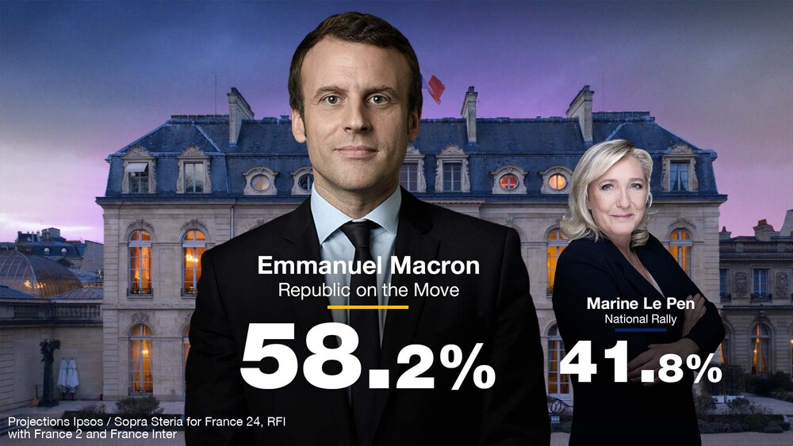
The abstention rate was put at 28.2% by Ipsos, up 1.9 points from the first round and 2.7 points from the second round in 2017.

- What might be benefits/problems be of getting your news through a ‘Live Blog’? How does this contrast with other forms of news?
________________________________________________________________________________________________________________________________________________________________________________________________________________________________________________________________________
- Political Spin: Look at the highlighted sections on the blog post to the left. How do these ‘spun’ versions of events agree with or contradict the data presented above it? Investigate the role of a ‘Spin Doctor’ in the modern political system.
________________________________________________________________________________________________________________________________________________________________________________________________________________________________________________________________________
- How close were the ‘exit polls’ compared with the final result? Would that influence how you view ‘exit polls’ in general? (Why might such a poll be easier in a ‘two-horse-race’)
______________________________________________________________________________________________________________________________________________________________________________________________________
- Why might the ‘Abstention Rate’ be important? Build you knowledge based on the previous articles.
________________________________________________________________________________________________________________________________________________________________________________________________________________________________________________________________________

French election results in charts & maps: Abstention & Le Pen gain ground
Le Monde (“Paper of Record” in France) April 25, 2022.
Abstention rates rose in the second round of the French presidential election and far-right candidate Marine Le Pen gained ground in several regions, including, most surprisingly, overseas.
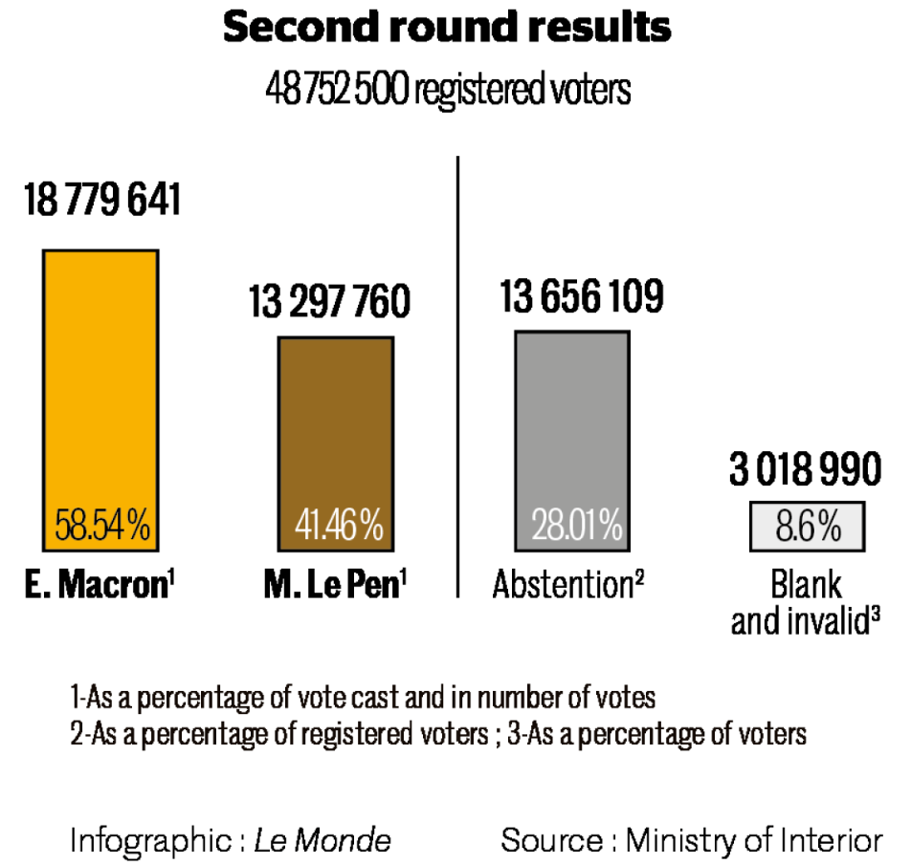
Emmanuel Macron won the presidential election with 58.54% of the vote on Sunday, April 24, compared to 41.46% for Marine Le Pen. The gap between the two has tightened since 2017, when their scores were 66.1% and 33.9%, respectively, with Marine Le Pen gaining ground in parts of the North, East, South, and overseas.
Both candidates and political leaders from all sides will be wary, though, of rising abstention rates.
Abstention, which has in recent years been described as the "third-largest party" in France, increased to 28.01% this year. In fact, in the second round, the number of abstentionists even surpassed the number of people who voted for Ms. Le Pen, which would make it the "second party."
More on this topic Macron earns a triumphless victory, tarnished by far right's historic score and fear of a 'third round'
Additionally, 8.6% of voters turned up only to vote blank – in other words, to cast empty ballots that are tallied, but not counted as part of the official results.

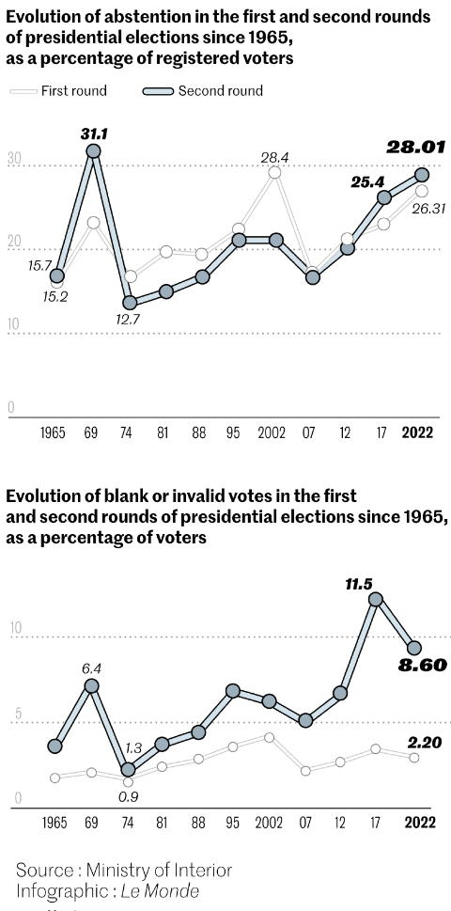
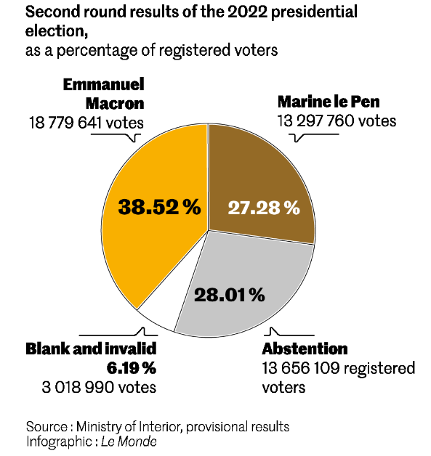
Therefore, placing the two candidate's vote totals as a share of total registered voters, as opposed to actual votes, offers a different perspective on the election result. The president was re-elected thanks to votes from 38.52% of French registered voters, a record low. In 2017, 43.61% of registered voters voted for him. Previously, François Hollande has scored in similar waters, with 39.07% of registered voters electing him in 2012.
These numbers illustrate what some believe to be a democratic problem. The spirit of the law behind France's runoff election is that, ideally, the winning candidate is chosen by a majority of French people. But the last president elected thanks to more than 50% of registered voters was Jacques Chirac in 2002. On Sunday night, left-wing politician Jean-Luc Mélenchon, who was eliminated in the first round, called Emmanuel Macron "the most badly-elected president of the Fifth Republic."
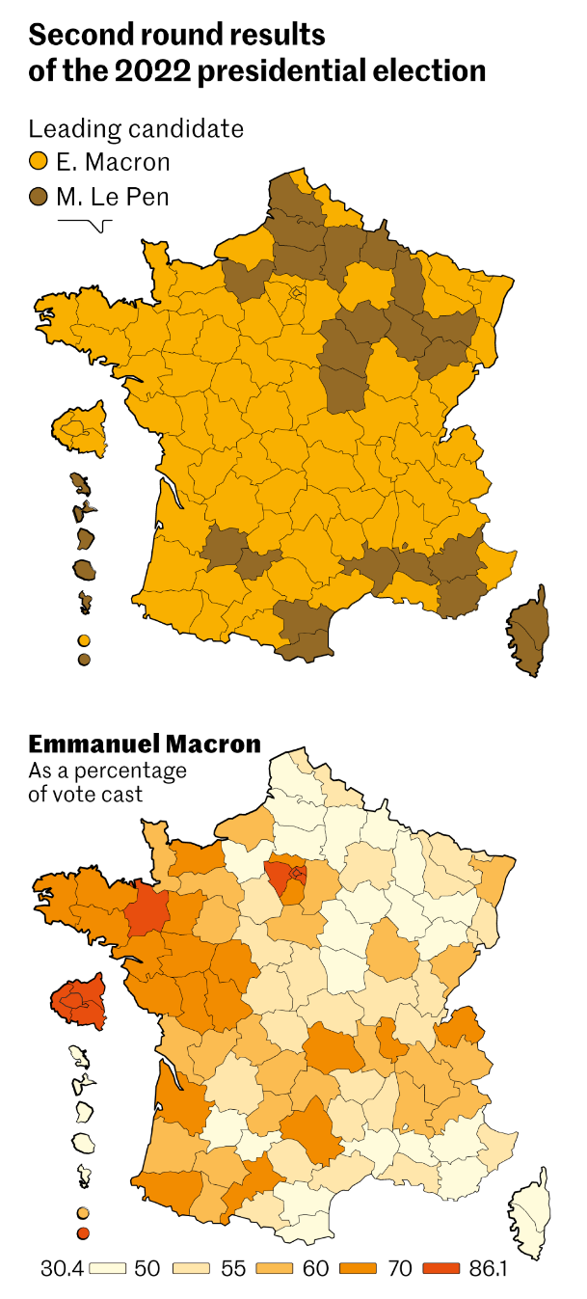
This year, abstention seems to have progressed because of a decrease in blank voting. The
number of blank votes decreased by three points from 2017's record high (11.5% of registered voters).
With 28.01% of registered voters not turning up, the abstention rate reached its highest level in a presidential election second round since 1969, when many left-wing voters stayed home as two similar right-wing candidates faced off in the runoff.
The first map shows Marine Le Pen's progress since 2017, when she only came top in two of France's 101 departments, both in northern France. This year, she beat Mr. Macron in 30 of them. She flipped many departments in the North and the East, two regions where deindustrialization and job losses have long helped the Rassemblement National in establishing strongholds.
Ms. Le Pen also gained ground thanks to a similar phenomenon in the South West, which was traditionally on the left. Several departments in the traditionally conservative South East also turned toward Ms. Le Pen, but fewer than in the first round.
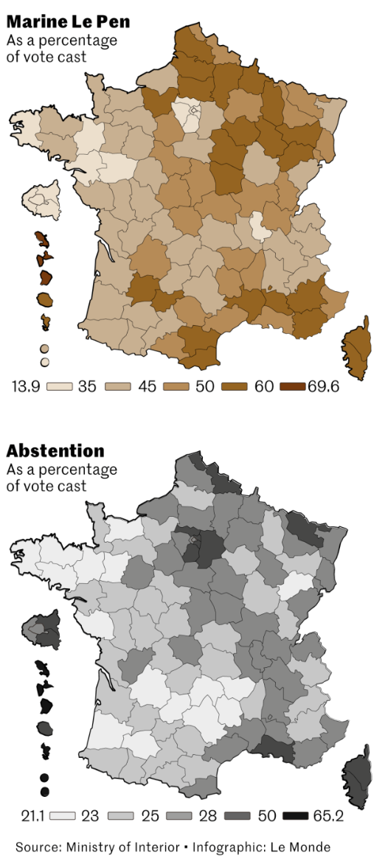
In the first round, she topped 42 departments. Mr. Macron took the lead back in 12, thanks in large part to votes from left-wing voters. These include departments where he was popular in big cities such as Marseille, Lille or Montpellier.
More on this topic 'The ideas we stand for are reaching new heights,' says Le Pen as she concedes defeat
Strikingly, Ms. Le Pen made very strong progress in overseas departments, including in some where the RN has historically been rejected, such as Martinique and Guadeloupe in the Caribbean. But Mr. Macron has very low popularity ratings in these territories. The example of Guadeloupe is particularly spectacular. After last year's riots against vaccination mandates, Mr. Macron's popularity plunged there. The island placed Jean-Luc Mélenchon in first (56.16%) in the first round, before shifting to the opposite end of the spectrum in the second round in favour of Ms. Le Pen (69.6%).

Emmanuel Macron benefitted from strong support in Brittany, the Western arm of France that reaches into the Atlantic, and in the highly-populated Parisian region of Ile-de-France. Both regions are historically hostile to the Rassemblement National and its ancestor, the Front National.
Corsica – whose relationship with French national politics is complicated at best – and many overseas territories were among the departments with the highest abstention rates. So were several of the suburban departments around Paris, in particular on the eastern side, which are among the poorest in France and often have large immigrant populations.
- Summarize the argument/perspective being conveyed by the article. How does it compare/contrast with the two previous sources?

- How do the historical comparisons presented in this article influence how you understand the issues at play in the election?

- What are the benefits of getting information from a “Paper of Record” like ‘Le Monde’? What does it suggest to you about your own “media diet”? What are the challenges in does this?

Infographics & Data
General Insights:
What are the general Strengths and Weaknesses of Infographics as a source of information? (Consider a ‘General Reader’ and the needs of an expert psephologist (a division of political science that deals with the examination as well as the statistical analysis of elections and polls)
Strengths:

Weaknesses:

Specific Insights:
How are those strengths and weaknesses evident in the visual presented in the article above? (Link the general ideas above with the specific elements in the article)

Which of the graphics did you find most useful in gaining a “Big Picture view of events in France” under the headings:
Globalization:

National Identity:

