How does John Locke help us to think more clearly about the issue of Covid-19 - limitations to movement and public health? Think particularly about how it relates to those who cry:

“I should be free to do as I please!” or “You can’t make me wear a mask!”

Coronavirus plus July Fourth raises a question:

What would George Washington do?
The founders endowed us with a system to handle COVID-19 responsibly. They also left us a record of how they managed public health crises.
Source: https://www.nbcnews.com/think/opinion/coronavirus-plus-july-fourth-raises-question-what-would-george-washington-ncna1232878

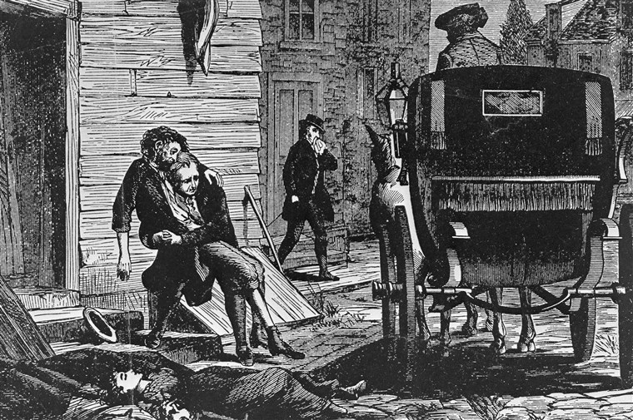
A woodcut of the yellow fever epidemic in Philadelphia in 1793 with carriages rumbling through the streets to pick up the dying and the dead.
Bettmann Archive
July 4, 2020, 9:30 AM BST
By Zachary R. Goldsmith – NBC News

With states such as Texas, Arizona and California closing stores and restaurants to rein in COVID-19 and cities nationwide mulling the requiring of masks in public, angry residents and business owners claim these restrictions violate the American idea of freedom. These measures clearly do involve hardships and exceed the normal restraints citizens expect from their governments in liberal democracies, but are they truly an affront to liberty?
The extensive body of writings, constitutional arguments and lived experience of the American pioneers of freedom and self-government, as well as those who inspired them, make clear that they are not. The founders endowed us with a system to handle the circumstances of an epidemic responsibly; we should be following their lead rather than trampling on their legacy, as well as the health and well-being of our fellow citizens.
In a crisis as profound as COVID-19, our founders would expect government to take all appropriate action.
Where better to start than with John Locke, the 17th-century thinker who arguably had the greatest effect on the political philosophy of America’s founders and who set the course for contemporary liberalism. Locke’s writings articulate a highly nuanced view of freedom, one far removed from the slogans displayed at protests decrying missed opportunities for a haircut or a meal out.
Locke revolutionized thinking about political power by arguing that the true source of legitimate authority rests with the consent of the people. Freedom means that every person is allowed to follow his or her “own will in all things” rather than be subject to the “arbitrary power” of another person.
However, Locke adds, freedom is not “a liberty for every man to do what he likes,” since “who could be free, when every other man’s humor might domineer over him?” True freedom — the freedom to be partners in our own self-governance — entails not only a freedom from external arbitrary power, but also a freedom from internal prejudices and other impediments (limitations) to reason.
Looking at scenes of protest around the country, and especially in my home state of Michigan, I am reminded of what Locke observed about a certain “mistaken” idea of liberty: If “true liberty” means to “break loose from the conduct of reason, and to want that restraint of examination and judgment, which keeps us from choosing or doing the worse,” in that case, “madmen and fools are the only free men.”
What Locke sketched out in theory, America’s founders knew in practice as political and military leaders, and enshrined in the laws and the guiding documents of U.S. government. The founders understood that government is necessary to “promote the general welfare” by facilitating collective responses to general problems — it’s even included in the preamble to the U.S. Constitution.
And, as Alexander Hamilton wrote in “Federalist No. 23,” it would be an “absurdity” to entrust to government “the direction of the most essential national concerns,” but then not entrust it with the authority that is “indispensable to their proper and efficient management.” Surely this means that in a crisis as profound as COVID-19, our founders would expect government to take all appropriate action. And we don’t need to speculate; we know they did from their records as political and military leaders combating diseases from smallpox to yellow fever.
As commander of the American forces during the Revolutionary War, for example, Washington “diligently quarantined soldiers who exhibited the first signs” of smallpox, notes historian Ron Chernow. When the threat grew acute near Boston during the winter of 1777, Washington ordered doctors to inoculate every soldier who had not yet been exposed to the disease. Chernow notes, “This enlightened decision was as important as any military measure Washington adopted during the war.” During this time, Washington instructed Secretary of War Henry Knox to, essentially, work remotely. “I think it would not be prudent either for you or the clerks in your office, or the office itself, to be too much exposed to the malignant fever,” Washington wrote. The president had decided to work from home himself, at Mount Vernon, telling a friend that he “could not think of hazarding” his wife and children by staying in Philadelphia.
Leaders on the scene, meanwhile, had no qualms about imposing regulations on the public for their own safety. Philadelphia Mayor Matthew Clarkson tasked prominent physician — and a signer of the Declaration of Independence — Benjamin Rush with compiling a list of public safety measures. Many, including the quarantining of all visitors and goods for two to three weeks, were adopted as new ordinances. The mayor also ordered a sanitation campaign throughout the city and requisitioned an abandoned estate for a makeshift hospital. Freedom worthy of the name takes difficult work and entails commensurate duties; it does not merely entitle us to shout with the loudest voice.
Today, the course of COVID-19 is far from certain, as is the ultimate number of lives it will claim. Rush wrote of the yellow fever epidemic that he worried about its future course, as well: “It is painful to look back on what we have seen, but more distressing to look forward. I fear we have seen only the beginning of the awful visitation.” Freedom, our political inheritance, is indeed precious and it must be safeguarded. However, a more nuanced view acknowledges that freedom worthy of the name takes difficult work and entails commensurate duties; it does not merely entitle us to shout with the loudest voice.
As we stand, I fear, at only the beginning of the “awful visitation” of COVID-19, we should attend to the lessons of Locke and our nation’s founders as we gauge the relationship between freedom and public safety in the weeks and months ahead.
Questions: - Before you begin, look up any of the words in bold with which you’re not already familiar… and keep a note of them for use in your own work!
- Evaluate the source of this article. Pay particular attention to what the ‘editorial position’ of NBC News and which US Political Party it generally supports. How might that influence how you interpret the argument presented in this “Opinion Piece”? Is the date of publication significant?
- What specific parallels does the author outline between the current public health emergency and those experienced in the 18th Century in America? Cite specific examples from the text.
- How effectively do you think that the author of this article has employed the ideas of John Locke (and the founding fathers’ actions) to provide useful insights into the current situation?
- Respond to the following statement, using the example of the text to guide the structure of your answer:
“Human Rights always depend on a clear understanding of Human Responsibilities”

Remembering that John Locke allows us to draw in multiple Natural Rights and Human Rights perspectives, examine this excellent graphic from @northmonpolsoc (who all Pol-Soc students should be following on Twitter). Look at how it draws together multiple contemporary contexts, proposing ways in which Covid has more starkly revealed some of the potential Human Rights issues brought into focus by Covid-19

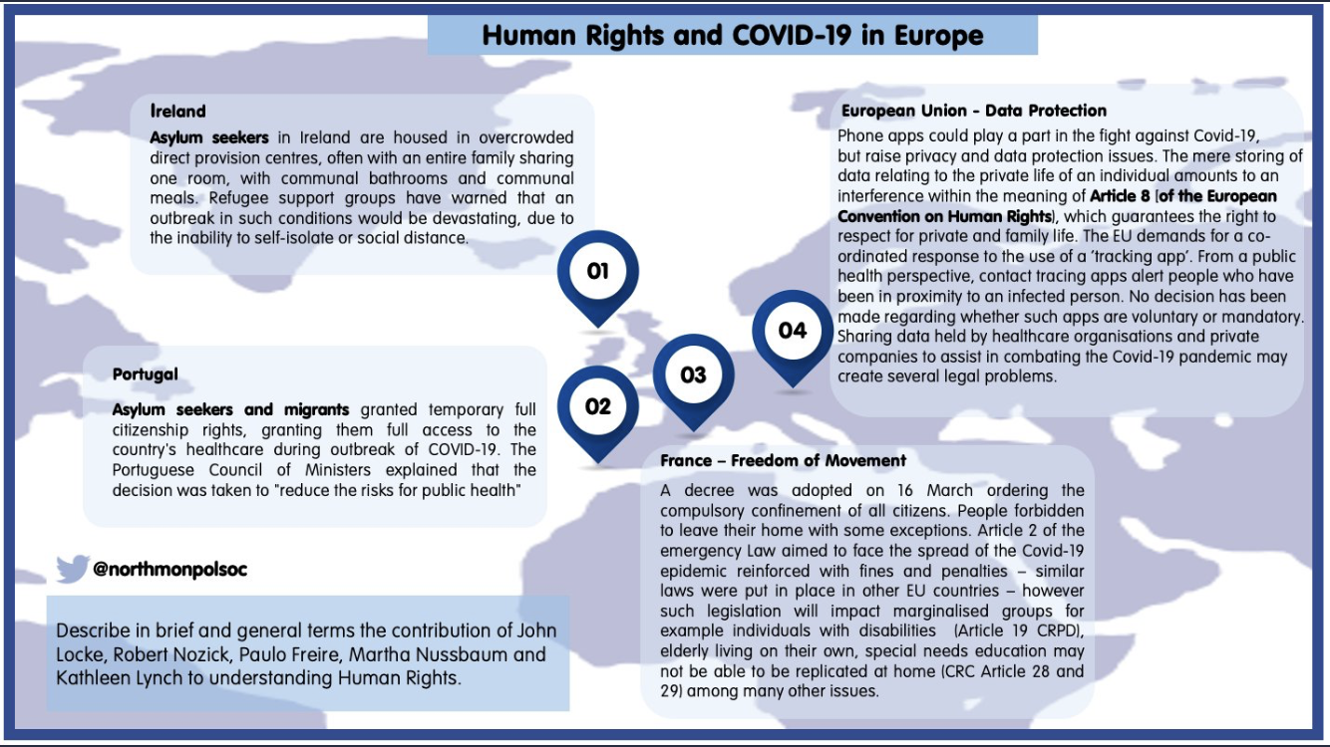
Look at this excellent infographic from @northmonpolsoc (if you’re not following this Twitter account, you should be!) Do you see how clearly it links Human Rights issues to Covid?

